6. Heap Sort
Aim:
To perform sorting using heap data structure

Theory:

Heaps
“A heap is a tree-based data structure in which all the nodes of the tree are in a specific order.”
For example, if X is the parent node of Y, then the value of X follows a specific order with respect to the value of Y and the same order will be followed across the tree.
The maximum number of children of a node in a heap depends on the type of heap. However, in the more commonly-used heap type, there are at most 2 children of a node and it's known as a Binary heap. In binary heap, if the heap is a complete binary tree with N nodes, then it has smallest possible height which is log2 N.
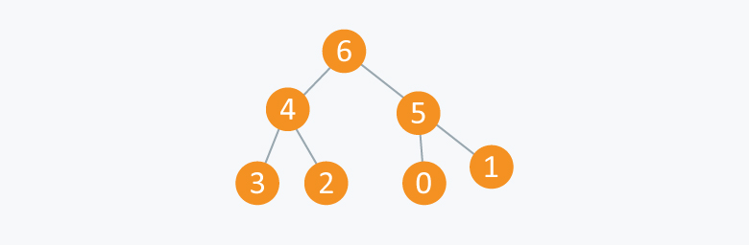
Figure 1: Example Of Max Heap

In the diagram above, you can observe a particular sequence, i.e. each node has greater value than any of its children.
An array can be used to simulate a tree in the following way. If we are storing one element at index i in array A, then its parent will be stored at index i/2 and can be accessed by A[i/2], and its left child can be accessed by A[2*i] and its right child can be accessed by A[2*i+1]. Index of root will be 1 in an array.

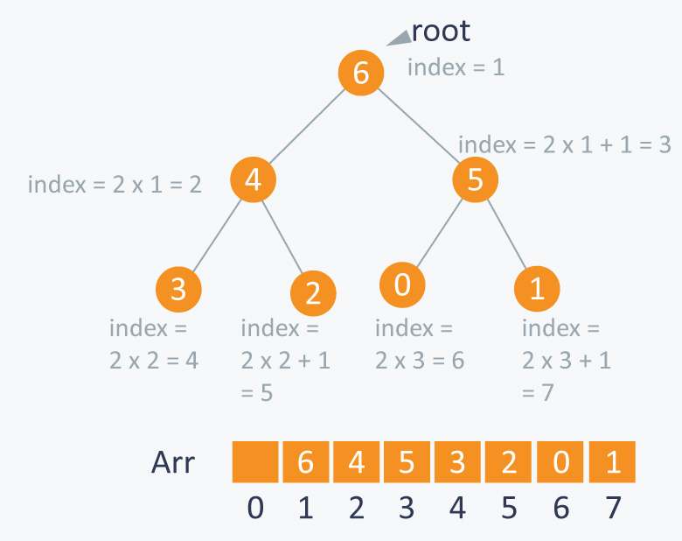
Figure 2: Array Representation Of Binary Heap Tree

There can be two types of heap:
- Max Heap: In this type of heap, the value of parent node will always be greater than or equal to the value of child node across the tree and the node with highest value will be the root node of the tree.
- Min Heap: In this type of heap, the value of parent node will always be less than or equal to the value of child node across the tree and the node with lowest value will be the root node of the tree.

Max Heaps
The way to convert a given array into a heap structure is the following. We pick a node in the array, check if the left sub-tree and the right sub-tree are max heaps, in themselves and the node itself is a max heap (it’s value should be greater than all the child nodes)
To do this, we implement a function that can maintain the property of max heap (i.e. each element value should be greater than or equal to any of its child and smaller than or equal to its parent). Complexity: O (log N).

void maxHeapify(int i) {
int temp;
l = getLeft(i);
r = getRight(i);

if(l <= heapsize && a[l] > a[i]) {
printf("\nLargest Element --> %d",a[l]);
largest = l;
} else {
printf("\nLargest Element --> %d",a[i]);
largest = i;
}
if(r <= heapsize && a[r] > a[largest]) {
printf("\nLargest Element --> %d",a[r]);
largest = r;
}
if(largest != i) {
printf("\nExchanging %d and %d",a[i],a[largest]);
temp = a[i];
a[i] = a[largest];
a[largest] = temp;
}
if(largest != i) {
maxHeapify(largest);
}
}

Building Max Heaps
Now let’s say we have N elements stored in the array Arr indexed from 1 to N. They are currently not following the property of max heap. So we can use max-heapify function to make a max heap out of the array.
From the above property we observed that elements from Arr[N/2 + 1] to Arr[N] are leaf nodes, and each node is a 1 element heap. We can use max_heapify function in a bottom up manner on remaining nodes, so that we can cover each node of tree.
void buildMaxHeap() {
int i;
i = size/2;
while(i >= 1) {
maxHeapify(i);
i--;
}
}
Example:
Suppose you have 7 elements stored in array:
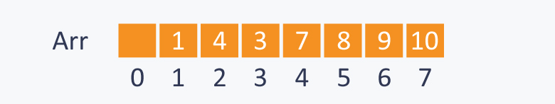
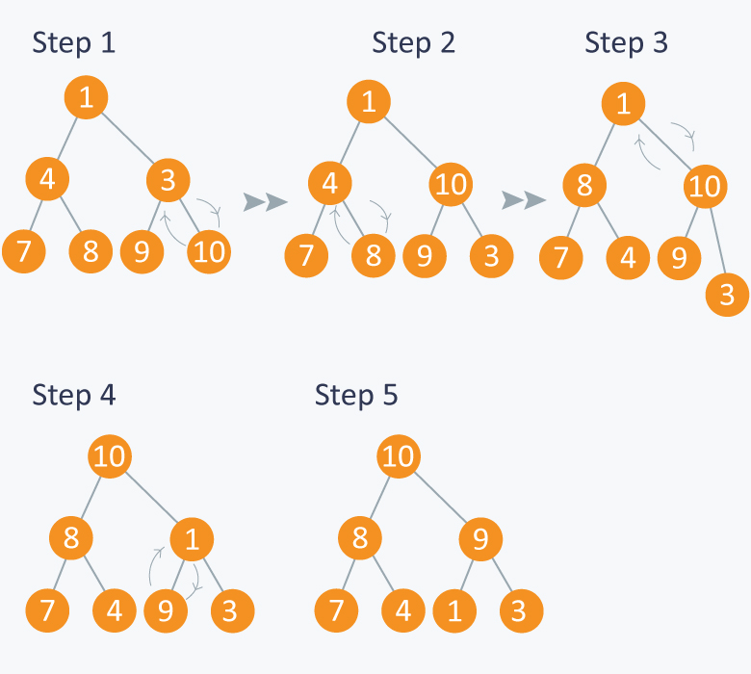
Here N=7, so starting from node having index N/2 = 3, (also having value 3 in the above diagram), we will call max_heapify from index N/2 to 1. In the diagram below:
- In step 1, in max_heapify(Arr, 3), as 10 is greater than 3, 3 and 10 are swapped and further call to max_heap(Arr, 7) will have no effect as 3 is a leaf node now.
- In step 2, calling max_heapify(Arr, 2) , (node indexed with 2 has value 4) , 4 is swapped with 8 and further call to max_heap(Arr, 5) will have no effect, as 4 is a leaf node now.
- In step 3, calling max_heapify(Arr, 1) , (node indexed with 1 has value 1 ), 1 is swapped with 10 .
- Step 4 is a subpart of step 3, as after swapping 1 with 10, again a recursive call of max_heapify(Arr, 3) will be performed , and 1 will be swapped with 9. Now further call to max_heapify(Arr, 7) will have no effect, as 1 is a leaf node now.
- In step 5, we finally get a max- heap and the elements in the array Arr will be :

Figure 3: Build Max Heap Example

Heap Sort
Heaps can be used in sorting an array. In max-heaps, maximum element will always be at the root. Heap Sort uses this property of heap to sort the array.
Consider an array Arr which is to be sorted using Heap Sort.
- Initially build a max heap of elements in Arr.
- The root element, that is Arr[1], will contain maximum element of Arr. After that, swap this element with the last element of Arr and heapify the max heap excluding the last element which is already in its correct position and then decrease the length of heap by one.
- Repeat the step 2, until all the elements are in their correct position.
void heapsort() {
int i, temp;
buildMaxHeap();
for(i = size; i >= 2; i--) {
temp = a[i];
a[i] = a[1];
a[1] = temp;
heapsize--;
maxHeapify(1);
}
}
Example:
In the diagram below, initially there is an unsorted array Arr having 6 elements and then max-heap will be built.

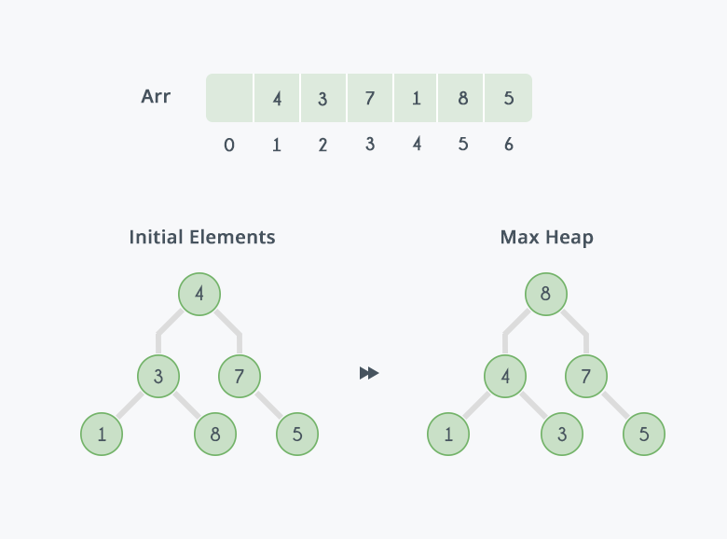
After building max-heap, the elements in the array will be:
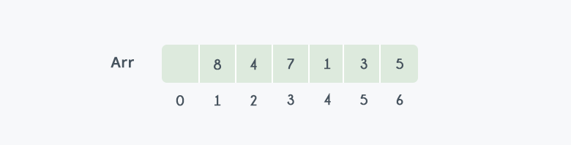
Step 1: 8 is swapped with 5.
Step 2: 8 is disconnected from heap as 8 is in correct position now and.
Step 3: Max-heap is created and 7 is swapped with 3.
Step 4: 7 is disconnected from heap.
Step 5: Max heap is created and 5 is swapped with 1.
Step 6: 5 is disconnected from heap.
Step 7: Max heap is created and 4 is swapped with 3.
Step 8: 4 is disconnected from heap.
Step 9: Max heap is created and 3 is swapped with 1.
Step 10: 3 is disconnected.
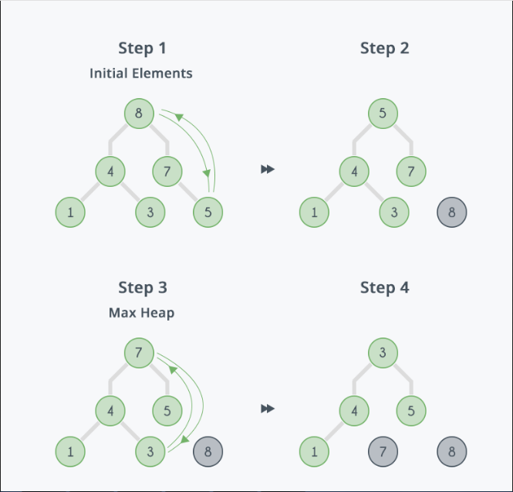
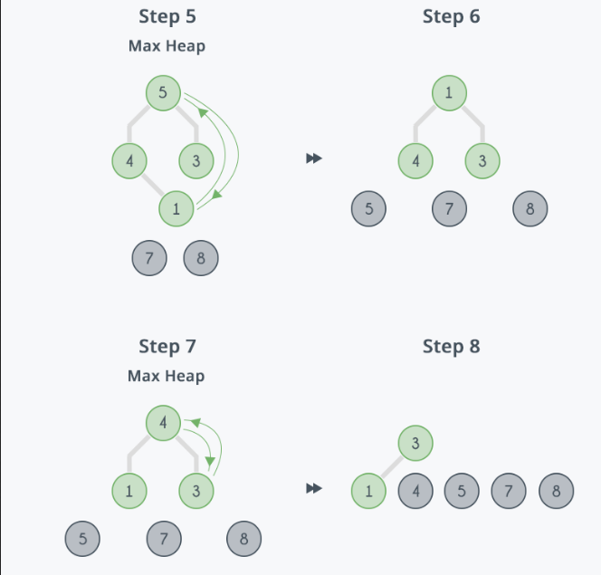
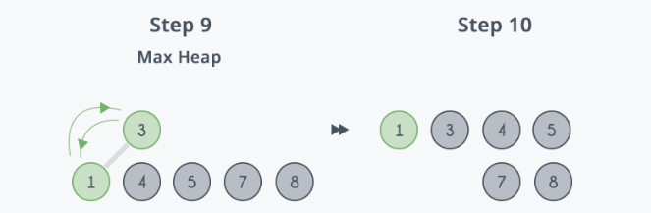
After all the steps, we will get a sorted array.
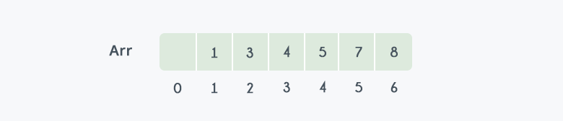
Figure 4: Final Output After Performing Heap Sort
Program:
#include<stdio.h>
#include<stdlib.h>

int a[50];
int size;
int heapsize;
int l, r, largest;

void printarray() {
int i;
for(i = 1; i <= size; i++) {
printf("%d\t",a[i]);
}
}

int getLeft(int i) {
return 2*i;
}

int getRight(int i) {
return 2*i + 1;
}

void maxHeapify(int i) {
int temp;
printf("\nMax-Heapify from element --> %d",a[i]);
l = getLeft(i);
printf("\nLeft child --> %d",a[l]);
r = getRight(i);
printf("\nRight child --> %d",a[r]);
if(l <= heapsize && a[l] > a[i]) {
printf("\nLargest Element --> %d",a[l]);
largest = l;
} else {
printf("\nLargest Element --> %d",a[i]);
largest = i;
}
if(r <= heapsize && a[r] > a[largest]) {
printf("\nLargest Element --> %d",a[r]);
largest = r;
}
if(largest != i) {
printf("\nExchanging %d and %d",a[i],a[largest]);
temp = a[i];
a[i] = a[largest];
a[largest] = temp;
}
printf("\n--------------UPON MAX-HEAPIFY()--------------\n");
printarray();
printf("\n");
if(largest != i) {
maxHeapify(largest);
}
}

void buildMaxHeap() {
int i;
i = size/2;
while(i >= 1) {
maxHeapify(i);
i--;
}
}

void heapsort() {
int i, temp;
buildMaxHeap();
for(i = size; i >= 2; i--) {
printf("\nExchanging %d and %d",a[1],a[i]);
temp = a[i];
a[i] = a[1];
a[1] = temp;
printf("\n%d is sorted in array",a[heapsize]);
heapsize--;
printf("\n-------------UPON EXCHANGING FIRST ELEMENT WITH LAST-------------\n");
printarray();
printf("\n");
maxHeapify(1);
}
}

void main() {
int i;
printf("\nEnter the size of the array: ");
scanf("%d",&size);
heapsize = size;
if(size >= 0) {
for(i = 1; i <= size; i++) {
printf("\nEnter data for element %d",i);
scanf("%d",&a[i]);
}
printf("\nUnsorted array: \n");
printarray();
printf("\n");
heapsort();
printf("\nSorted array: \n");
printarray();
printf("\n");
}
}

Output:
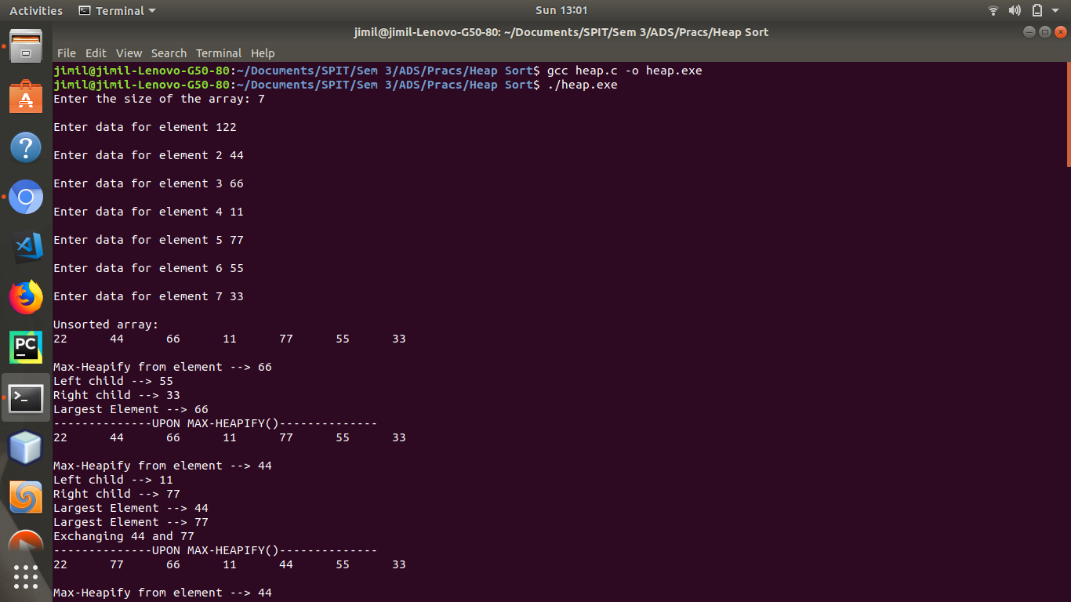Figure 5: Input Size of the Array and Elements Of The Array
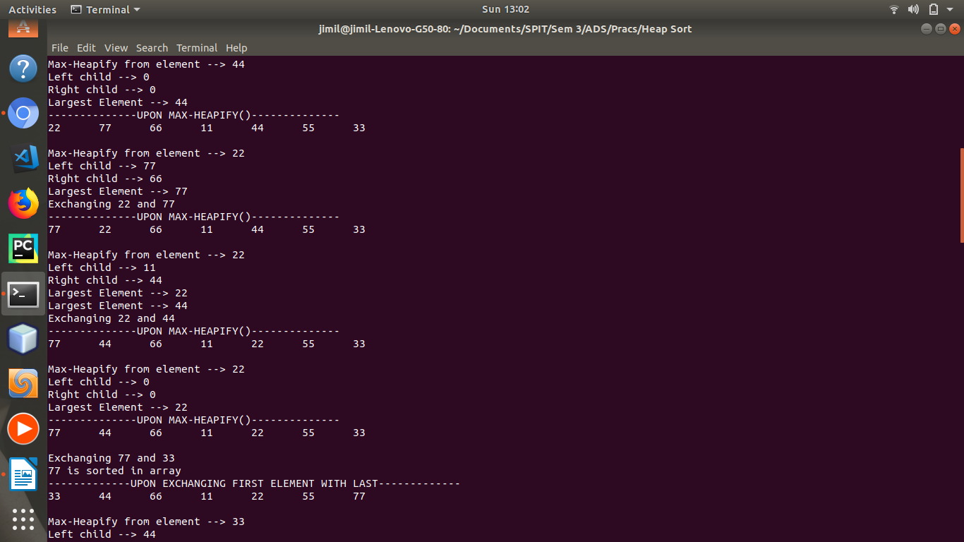Figure 6: Intermediate Step 1

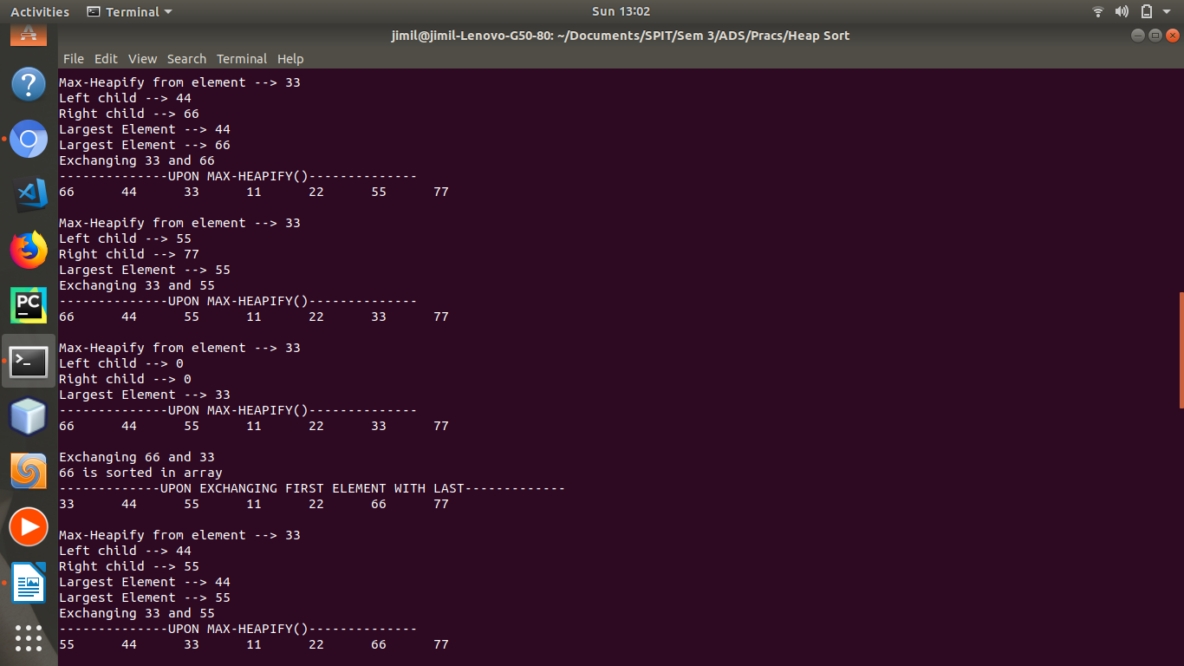Figure 7: Intermediate Step 2
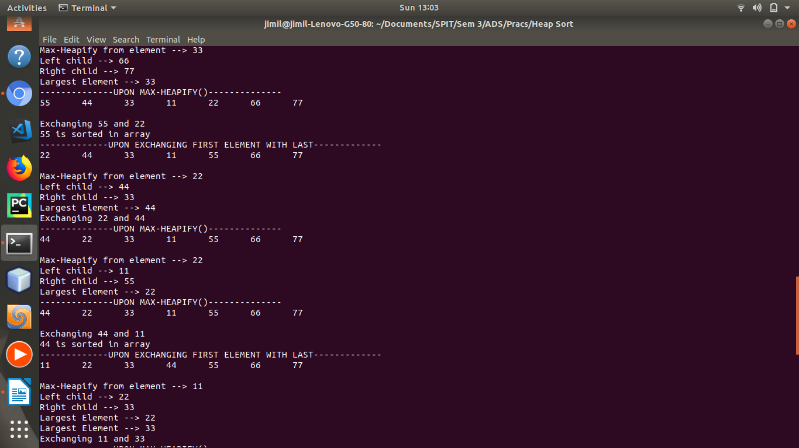Figure 8: Intermediate Step 3

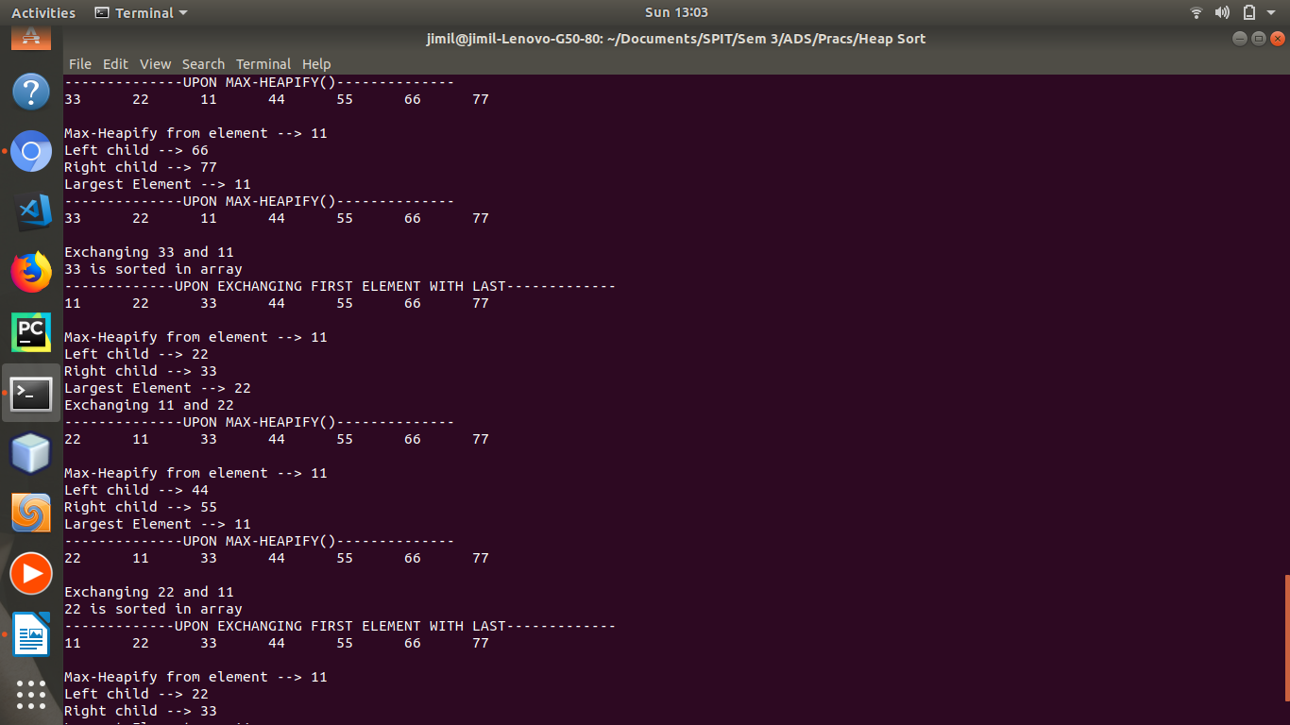Figure 9: Intermediate Step 4
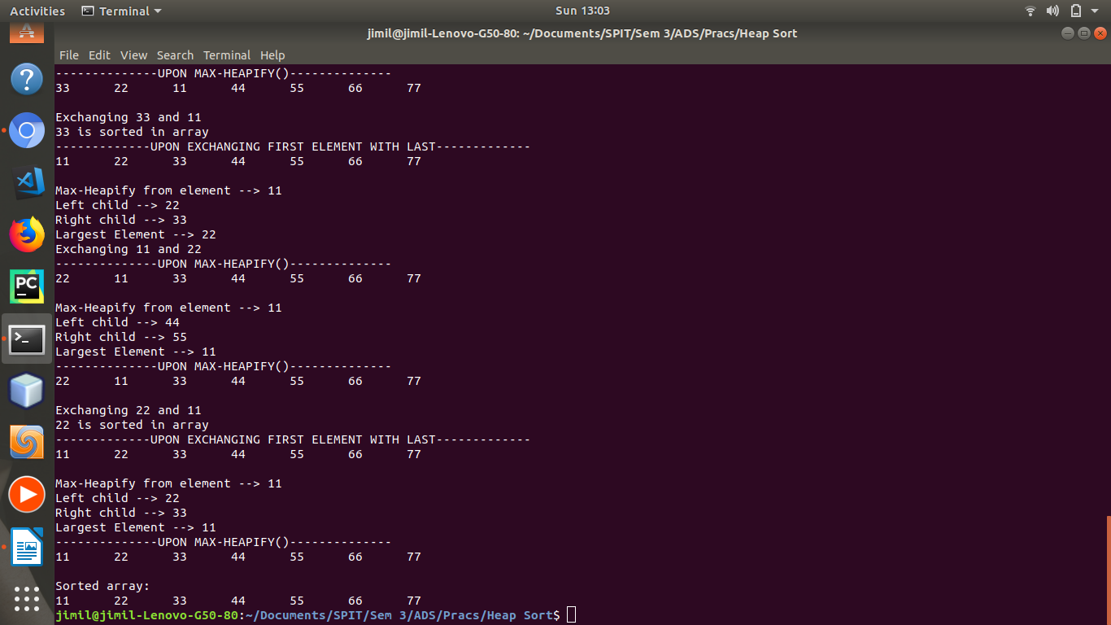Figure 10: Sorted Array

Result:
Heap sort is a sorting algorithm with a running time of O(N log N). Heapsort sorts in place: only a constant number of array elements are stored outside the input array at any time. Heapsort combines the better attributes of insertion sort and merge sort.
Heapsort uses heap data structure for managing information. It also makes for efficient priority queue.
Suppose there are N Jobs in a queue to be done, and each job has its own priority. The job with maximum priority will get completed first than others. At each instant, we are completing a job with maximum priority and at the same time we are also interested in inserting a new job in the queue with its own priority. This can easily be done using heap.

Conclusion:
Thus, we have understood and implemented heap data structure. There are two types of heaps: max-heap and min-heap where for a max-heap the value at parent is always greater than or equal to its children.
We used heaps to perform heapsort on a given array of unsorted numbers using three functions namely, max-heapify, build-max-heap and heapsort. The program yielded a sorted array.

